1. What are the different methods to call a function in R?

* Calling a Function without an Argument

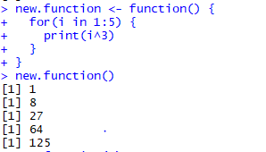

* Calling a Function with Argument Values (by position and by name)

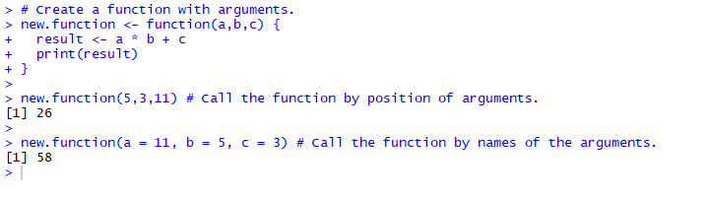

* Calling a Function with Default Argument

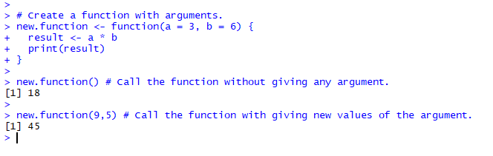

1. The lazy evaluation of a function means, the argument is evaluated only if it is used inside the body of the function - False.
2. State True or False:
3. Insights driven from descriptive analytics is not meaningful – True.
4. The number of values in each Elements of a list, should be equal – False.
5. The datasets are not stored in memory of the computer using R - False
6. Data frames and matrices are two dimensional however the array is multidimensional - True